The Memoirs of Nera Aquilae --Child of the Green--Chapter 12
My eyes felt heavy. I closed them and entered the elven trance. But this time my dream was different. For the first time in many long decades, I did not dream of my lost love and the heart ache and pain of the spirit that it brought. For once I did not feel cursed. Instead, a feeling of peace, love and joy enveloped me, something I had not experienced in an extremely long time. Almost forgotten feelings.

Under a tapestry of stars, a warm breeze bathed me. In the distance, I could hear a bard tickling the strings of her lute. The perfume of wildflowers assailed my nostrils. I became entranced by warmth and tranquility. My hand felt a gentle touch. It was as how my lover used to touch me; soft and caring. I turned my head, look up, and now I can see Her; so pretty, so pure. I am unable to determine if she is human, elf or even half-elf. But it does not seem to matter.

She is surrounded by an aura of radiant light, her clothing a white gown with a purple robe. Her belt is a garland of flowers. Her only ornaments a necklace of jade and a matching bracelet. Her hair is long and the colour of moonlight, adorned with both white and purple flowers. Her head sprouts a magnificent set of proud antlers. One hand is touching mine while the other holds a flowered staff. I perceive its power. Two paragon deer accompany her. Fliting about her, laughing in play, are tiny sprites and faeries. A cloud of butterflies, some white, some purple envelope them all.
In a voice melodious She asked: "Nera Aquilae, Child of the Green, will you accept my gifts, be mine forever and spread my words of desire?"

My eyes are streaming tears as I again can experience feelings of joy and love. My heart is filled with light, instead of pain. I looked up at the beautiful face staring down at me and hold on to her hand. "Yes" I state, "help me make amends for my lost love and I will be yours." Warm sunshine was her smile. “So let it be.” Then I woke to find the night watches had ended.

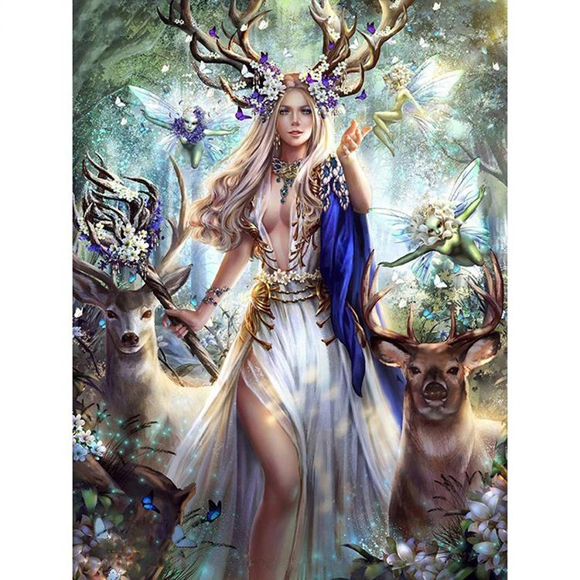
The goddess Shaneenah as seen in Nera’s vision

The others were looking at me strangely. “Nera”, requested Vlad, “are you alright? You were having slight convulsions. We were afraid for you but feared to wake you.”
I let out a glad laugh. This startled them. I had not laughed since I learned of my lover’s demise, so, so long ago. Was I alright? I was more than alright. I had experienced bliss. I was slightly giddy. The Green filling me now mingled with the Light of Shaneenah. I stood. I replied, “Concern yourselves not. I am well.” Then I gave a happy smile which disconcerted them.
This from MooGoo, “Something is wrong. Bug-Woman acting strangely.” His hands moved to grip his great axe. I gave the half-orc my full attention. The Light of Shaneenah had freed my spirit but had also instilled a fey aspect, the mischievous kind. “Oh, my brave barbarian, nothing has changed” I giggly retorted. I whispered a word of power. My eyes became fey, a brilliant solid blue.
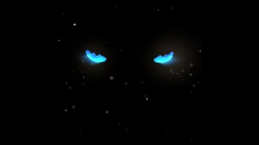Nera’s fey eyes.

MooGoo took a step back, on guard. I continued. “MooGoo, MooGoo, once you said you trusted me. Trust me no longer?” A second whispered word of power. The sound of a cat purr in his ear. He spun around, searching.
Somehow Faeril could discern what I was doing. “Nera, stop playing! MooGoo, at ease. I detect no evil here.” Her words settled me. “You are correct Faeril. There is no evil. I apologize MooGoo. I apologize for teasing you so. It will not happen again…until next time the fey in me cannot resist playing a prank. And not just on you friend MooGoo.” I dismissed the blue eyes.
“It was the tablet we found, wasn’t it? questioned Bruenor. Naturally the wizard would want to know every detail. I was reluctant to explain my dream. I simply answered “Yes, it was.”
Faeril seemed to understand. Was her Oblok experience similar? “The tablets, yes. I have one and am still Faeril, and now Nera has one and is still Nera. That’s it. Now we return to Ouzo’s tribe. It is a two-day trek. Let us prepare.” Her tone brooked no hesitation. Bruenor kept pestering me with questions. I ignored them. He finally gave up.
The first ‘day’ was uneventful. There had been no encounters. We found a secure area to sleep. First watch was Vlad and Bruenor. I entered my trance. It was different. No longer the times with my lost love. No longer the guilt and the pain. I walked in Shaneenah’s domain, caressed by grass and breeze. There is luminosity. Tiny fey fly and play. Flowers and butterflies, singing birds in tall trees. Animals frolic. I know who I am; I belong to me and only me. I raised my arms in delight of the senses, seeing, feeling, hearing. I inhaled fragrant fresh air. I had no boundaries. I was independent. I felt joy and contentment. I realized my obligation; to bring others into Shaneenah’s Light so that they too could experience the gratification and the happiness, as I, of Her glory.
Vlad wakes me. Bruenor does the same to Faeril. Korit too finishes his trance. We three keep watch. The others fall asleep. Then Faeril speaks: “Nera, I know you and Korit had doubts about our return to the drow. I know you discussed leaving on your own.” How did she know? Neither Korit nor I ever spoke to anyone else. Another of Faeril’s secrets? She continued: “Ease your fears. Once we possess the Chief’s tablet, we will make our way to the surface. Forget the drow. Retrieving the tablet for Vilania was the only way she would let us go. I do not trust the drow.”
“Well, that is a relief” was Korit’s response. “The others?”
“Can be persuaded to not return to the drow outpost” finished the half-elf.
“Good.” Then he addressed me. “Nera, the tablet? MooGoo was correct. You did act different. Is all well now?” I gave a chortle as I looked away. The tricksy fey had bubbled up. I gave myself red panther eyes and replied “Korit, all is well. I am no danger to you or any other.” Then I turned to again face them. They see my eyes.
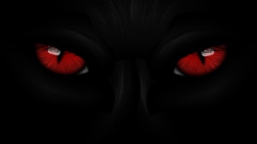 Nera’s panther eyes.
Korit’s surprise forced him to give a gasp. Faeril was unfazed. “Nera, stop. You must learn to control that teasing instinct, that feyness. Act as an adult, not as a child having to show off a new toy. It is fine Korit. It is just Nera playing at your expense. Her words did supress any further actions. I was going to make the ground jiggle under Korit’s rear. But how did she know? How was she so informative? Of course, Oblok. The tablets must know each other. And with that realization, I now understood Faeril’s Oblok given abilities.
“Forgive me Korit. Faeril is right. I must control my new abilities. It’s just been too long since I had any…any fun. Fun is such a temptation. But my fun should not be at an innocent’s expense. I must model the gifts of Shaneenah. I have a duty to those sick in spirit and heavy in heart, those unsure of themselves, those unhappy in their lives, those unable to love. I can lead them to accept Her, fill themselves with her Light and become whole, self-assured, joyful in play, rejoiceful in life and love. As She has done for me, given me back my joy, allowed me to, again, breathe free, this She can do for others, for you. Your burdens, dear friend Korit, burdens of both soul and mind, She will lift them. It is simple. Take Her into your heart, stand in Her Light. You can do so now.”
Korit just stared at me, for a time, silently. Then he responded. “Nera, I know you mean well. You want to help. My burdens are mine alone to resolve.” I expected that. It was too soon. I nodded. “Fine. Remember, remember when the burdens become smothering and crushing, remember my words. Remember Shaneenah’s radiance.” Korit nodded in return. Silence followed.
Eventually third watch came. MooGoo relaced Faeril.
We three sat quietly for a span. Then MooGoo asked. “Sneaky, is Bug-Woman still Bug-Woman?” I sighed and replied as Korit let out a chuckle. “Yes MooGoo, I am still me except now I can do …ah, .do more things.”
“Like change color and shape of eyes and make pussy purr in MooGoo’s ear?”
“I should not have done that…but the look on your face was priceless. I am sorry. Yes, that and some other things.”
“Bruenor said tablet changed you.”
“It did It has made remember what happiness and love were. It has returned my joy of just being alive. I want to teach others how easy it is to regain these feelings, how their burdens can be removed.”
Korit interjected. “Save it Nera. I doubt our friend MooGoo has any burdens, not physical, emotional, or spiritual.”
“Sneaky speaks true. Nothing burdens MooGoo; except feel sad if had to hurt changed Bug-Woman. MooGoo glad Bug-Woman is still same Bug-Woman but who now likes to be alive. No hurt needed. Keep watch.”
There was not much else to say. MooGoo was telling me, in his own way, that he accepted how the tablet had changed me and would treat me as he always had done. I experienced happiness.
Early next ‘morning’ we set off; Korit leading. Ouzo was near the rear. He said his only purpose was to protect Iksara. In the Underdark it is extremely rare to go two consecutive ‘days’ without something trying to kill you and then eat you. It happened shortly after our lunch break. It emerged from a darkened lair; something I, in all my time of wanderings, had never confronted. Even so, there was no doubt; to the Green it was an abomination! Fil’viridi recognize two main abhorrence, the undead, as they do not allow the circle of life to close, and the aberrations, as they are parodies of natural life forms.
How best to describe it? It was large, around 500 pounds. It had a bloated, oval-shaped body 8 feet wide. It stood on three shuffling elephantine legs. Its hide was rock-like. A pair of long tentacles, bedecked in rough thorny growths, ending in leaf-shaped pads which bore rows of sharp spikes sprouted from each side. A third tentacle rose from the top of the body, forming a vine-like stalk standing some 2 feet high, and ended in a pair of eyes with an olfactory organ. The body of the creature contained a massive fang-filled mouth, shaped like a crude gash through its center. Bruenor knew exactly what it was. “Otyugh!” he shouted.
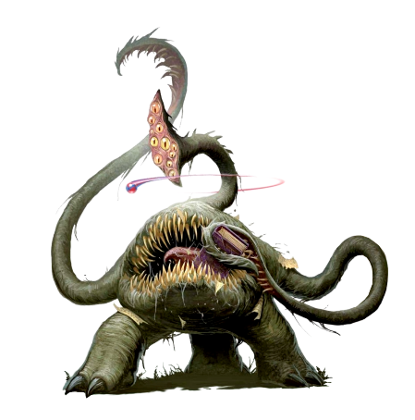
So swift was its attack that Faeril and MooGoo were surprised. I was not. I produced a handball of fire. I threw it. The monster squealed as it burned its flesh. This galvanized everyone. Bruenor’s firebolt seared it again. Naturally, as Korit tumbled to avoid the flaying tentacles, Vlad unhesitatingly, charged in, only to be swatted aside by one. Oh, my young impetuous fighter.
The others recovered enough to join in. Faeril blessed MooGoo, herself and Vlad. MooGoo charged, his great axe biting deep. Before he could strike again, a tentacle encircled him, grappling him. MooGoo was injured and being slowly squeezed but that did not stop him from continuing to slice the monster. My friend was hurt, fighting for his life. I felt another emotion, again one I had forgotten, anger; not the hot kind, but the blue, calculating one of the fey.
I arrived at the monster’s side, unnoticed, as it was attempting to bite Faeril, who had just smite-stabbed it. I called upon Shaneenah’s Light. I placed my hand upon the otyugh’s tough hide. I released necrotic energy. I felt the energy eat away at its lifeforce. It shrilled in pain. And again, as a salvo of Bruenor’s magic missiles burrowed into it. disintegrating flesh and bone.
By now, Faeril, Vlad and Korit were using sword and rapier to repeatedly stab into it. In agony, it flailed. Its grabbling tentacle slammed MooGoo against a rock base. Anyone else would have been smashed, but this was MooGoo, granite tough. He released his killing rage.
Again, I injected necrotic energy, depleting its lifeforce. This forced a mistake. It attempted to eat the half-orc. This brought MooGoo face to face. The first swing of the great axe cleaved the sensory organ. The second swing went directly into the top of the head, cutting through the hide and splitting whatever the otyugh used as a brain. It collapsed; the tentacle relaxing and freeing MooGoo. Faeril and I rushed to him.
His chest bore a series of red sucker marks where the pads had stuck to him. All around these marks were a sets of bleeding punctures where the thorny spikes had penetrated. The pressure had cracked ribs.
Faeril laid on hands to apply divine energy healing. I seeped soothing Green curing. The ribs knitted. The wounds closed. MooGoo stared up at us. “Hair-Woman. Bug-Woman. MooGoo thankful.” Faeril patted his arm. “And we are thankful to have MooGoo.”
Then we were assailed by an overwhelming putrid stench of offal and rot. Bruenor had not detected magic and so had persuaded a naive Vlad to slice open the otyugh to expose its innards, Just in case it had consumed valuable items. There was nothing except excrement. What a surprise! We held our breath and quickly left the area.
Near supper time, we arrived at Chief’s tribal encampment. We were hailed as heroes. I managed to trade my basilisk stomach fluid vials for a prepared potion of stone to flesh. We were treated to a feast of…fish and mushrooms stew. Chief brought out the tablet, our reward. Then he began to speak. Faeril translated: “Heroes, the rescue of my daughter strengthens the tribe. The destruction of the Red Flame tribe has increased safety and security in the region. But you do not belong here in the Underdark. So, I make this request. Travel to the area of the basilisk herd. Eliminate them and extract their stomach fluids. Do this and I will have Ouzo guide you to the upper world. Will you decide?”
Korit, Faeril and I glanced at each other. This was better than expected. We had already agreed to head for the surface. Faeril addressed the others. “Well, we either accept or return the to the drow. Frankly I want to see the sky again.” Korit added, “we do have Angela’s map. We can coordinate with that.” The discussion was short. All agreed.
With that, Chief held out the tablet. Bruenor quickly snatched it. “I can translate the words” was his excuse. He perused the inscription and then reported: “It is the tablet of Bheleu, the one Viliana directed us to find. It reads: Before creation comes destruction Give up and surrender, I must destroy. Uhm, interesting.” The tablet was passed around. Holding it, I felt a kinship of sorts, of related tablets. Passing it to Faeril, I noticed that it affected her in the same way. Vlad was the last to hold it and the first to speak of it. “It’s heavier that it looks and so warm to the touch.” No one else had noticed that.

We decided to keep our own watches, not to rely solely on the lizardfolk sentries. The watch order was the same. It was second watch. Faeril, Korit and I guarded. Korit drew our attention. “Look at Vlad.” He was having slight convulsions and perspiring. “That was you last night Nera. He is doing exactly as you did. I suggest we treat him the same.” We did, just ensuring he couldn’t harm himself. He awoke hours later only to see us staring quizzically.
“I have a ringing in my ears” were his first words.
“It must be tablet. You had a vision, didn’t you? Tell us!” That was Bruenor, anxious to know details. Unlike myself, Vlad was willing to share his dream.
“I found myself standing on a ridge. From a distance, filling my ears, were sounds of battle and war drums. Instinctively, I tightened my grip sword and shield. I scanned the horizon for approaching foes. Then I noticed swirling shadows moving up the ridge. Then they stilled to reveal, towering over me, a huge Half-Orc warrior. He was a half-orc unlike MooGoo, unlike any I had ever seen or heard of before. He appeared to be enveloped in tentacles of living darkness. I do not know how I knew, but he was a remnant of a race destroyed during the Age of Dragons. He strode towards me. I knew I was overpowered, but still, I would resist. I would fight back till the end. I raised my weapon and readied my shield.”
“He spoke then; his voice, as thunder, booming over the din of battle and drums, "Vlad, named the Impetuous, you do not cower. You would contest me in combat? By this you show your worthiness. Accept me, join me, spread my word and we will fight as one on the field of battle!"
“I felt his power then. He was Destruction and Construction. Somewhat like your Circle of Life, Nera. The old must give way for the new. Death and then Re-Birth. Except at times the old must be forced to give way to the new. I could accept that. I dropped to one knee and replied firmly, "I will. There was a deafening thunderclap and a bolt of lightning struck me square on the chest There were no visible ill effects. A mystical energy now coursed through my heart and soul. I woke to find you all around me.”
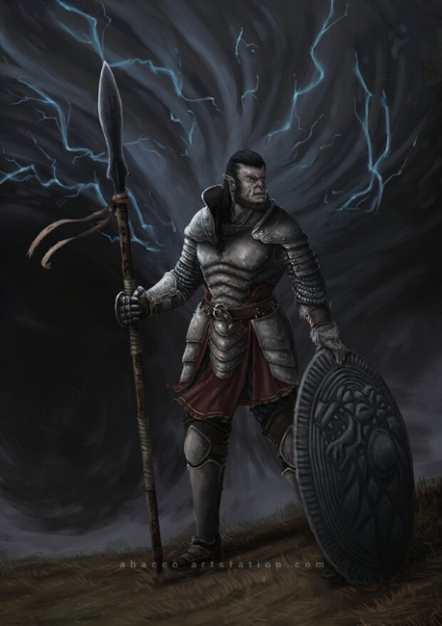
The god Bheleu as seen in Vlad’s vision

“The Age of Dragons” mused Bruenor. “Interesting. Oh, thank you for sharing, Vlad.” He gave me a reproachful look, as if to say, why are you not also sharing? “How are you feeling now, Vlad?”
“Fine, Bruenor, just fine. I feel energized, as if I was taken apart and put together improved.”
“Destructed and then constructed” was my thought.
“So, tablet change Baby-Fighter? That was MooGoo.
“Yes but like Nera, Vlad is still Vlad.” That was Korit.
“So, no changes. Baby-fighter still fight like baby.”
MooGoo’s statement caused me to bark a laugh. The fey in me wanted to join in; to cause happy baby sounds seemingly to emanate from Vlad’s mouth. I resisted.
Shortly after, breaking our fast, we set off. Ouzo leading us to the basilisk lairs. Eventually we arrive at a cavern. Faeril reported: “Ouzo states that we must pass through this cavern to reach the basilisk lairs. He will wait for us.”
We enter. There is an ashy material on the floor whose layer thickens as we proceed. MooGoo tells us that the cavern walls have cracks, out of which is the ash material is leaking. Bruenor sends the Professor ahead to scout. The owl familiar flies about 50 feet when it suddenly disappears. Korit, who was the closest, with his keen elven sight, saw what occurred. “A stirge! It took out the professor.”
Stirges I knew. I had encountered them many times in my travels. Think of a cross between a large bat, an oversized mosquito, and a crow. Despite their odd appearance, they are natural beasts. And bloodsuckers!
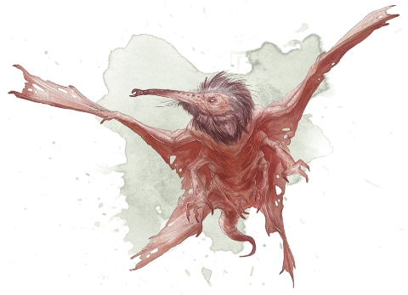I knew where there was one stirge, there would be a flock of them. “We can avoid them”, I declared. We go, single file, silently and hiding. If we are not bleeding, they will not detect us.” I used the Green to allow us to pass without trace. It would have worked except for one misstep. We were halfway through, ash up to our knees, when Vlad slipped. His metal armor made a loud clang as he hit the rock wall. He was no longer hidden. This aroused the flock and they swarmed us.
Three of them flew at me. They swooped down, eager for my blood. I called upon Shaneenah’s Light. A cone of fire burst from my outstretched hands, engulfing, and incinerating them. Charred bodies fell into the ash. This exposed me. Another triplet attacked. I managed to dodge two but the third latched onto my shoulder. Its sharp needle-like proboscis pierced deep. Then it and its two companions were blown apart! Bruenor’s magic missiles. I mouthed a thank you to the dwarf. The remaining stirges suffered a similar fate. Due to Faeril’s eldritch blasts. The air was now free of them.
Korit had stormed ahead to an area where the passage widened. He beckoned us. “Move, people, move. Now is the time. “We began to dash to reach him. As I started, I felt a painful bite on one leg, then on the other. Vlad’s cry told me he too suffered a bite. I felt poison enter my legs, flowing up. It was agony. I could not see into the ash. Whatever had bitten me moved easily through the ash; could easily see through the ash and could inject poison. I was getting weaker. The walls were too far away for me to reach and climb. I would get bitten again and again. I took a chance. Only one creature could do what my attackers did. I hoped they would not attack their own kind. I wild shaped. I became giant centipede. I fell into the ash.

